Book Your Dental X-ray: Orthopantomogram (OPG) and Lateral Cephalogram Online at Butler Medical Imaging. (08) 9544 3999

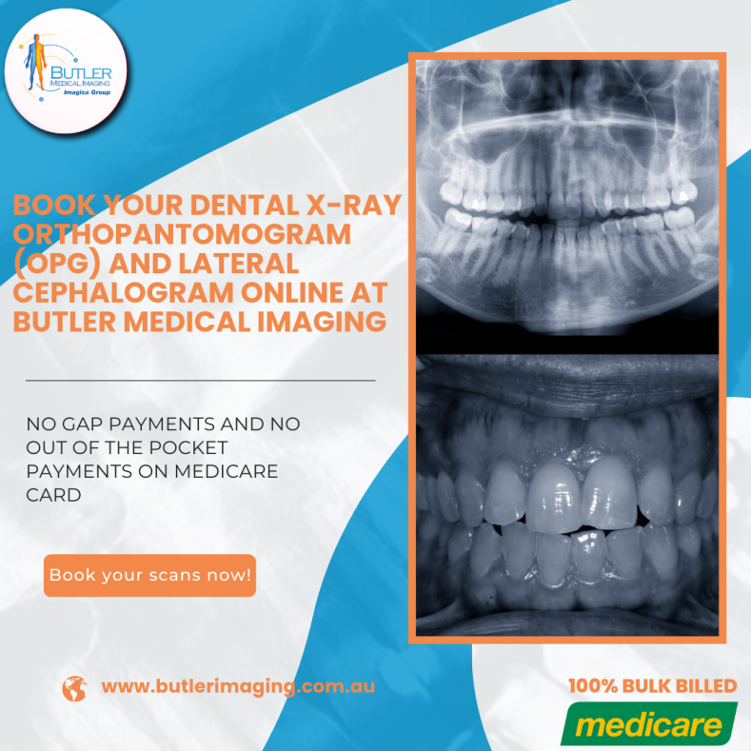At Butler Medical Imaging, we offer essential dental imaging services, including Orthopantomograms [(OPGs)](https://butlerimaging.com.au/dental-xray-opg/) and lateral cephalograms, two types of specialized X-rays. These X-rays provide comprehensive insights into the structure of your lower face, teeth, and jaw, making them crucial diagnostic tools for various dental and orthodontic treatments.

### Understanding Orthopantomograms (OPGs)

An Orthopantomogram (OPG) is a panoramic dental X-ray that captures an image of the entire mouth, displaying all teeth, the upper and lower jaws, and surrounding structures. Unlike traditional intraoral X-rays that capture images of a few teeth at a time, the OPG provides a broad view, helping doctors assess the overall dental and skeletal structure.

### Key Uses of an OPG

**Assessing Teeth Position and Development**

Dentists and [orthodontists](https://butlerimaging.com.au/dental-xray-opg/) rely on OPGs to view all teeth, including those that haven’t surfaced yet. For patients with developing teeth, like children or teenagers, the OPG offers valuable insight into teeth alignment and potential issues, aiding in orthodontic planning.

**Evaluating the Temporomandibular Joint (TMJ)**

TMJ disorders, often characterized by jaw pain, clicking sounds, or jaw locking, can be evaluated through an OPG. The imaging reveals any misalignment or structural abnormalities in the jaw joint, helping doctors determine the best course of treatment.

**Pre-Surgical Planning**

An OPG is commonly used for pre-operative assessments, particularly for procedures that require careful planning, such as dental implants or jaw surgeries. It’s also employed in planning non-dental surgeries, like a [Coronary](https://butlerimaging.com.au/dental-xray-opg/) Artery Bypass Graft (CABG), where understanding oral health and potential infection sources is essential.

### Understanding the Lateral Cephalogram

A lateral cephalogram is a specialized side-view X-ray of the head, primarily used in orthodontics to evaluate jaw alignment and facial structure. The cephalogram provides a detailed view of the facial profile, showing both bone and soft tissue, making it instrumental in orthodontic and surgical planning.

### Key Uses of a Lateral Cephalogram

**Orthodontic Treatment Planning**

Orthodontists use lateral cephalograms to assess jaw positioning and the relationship between the upper and lower jaws. This [X-ray](https://butlerimaging.com.au/dental-xray-opg/) is particularly helpful for diagnosing overbites, underbites, and other bite-related concerns, as well as tracking changes over the course of treatment.

**Growth and Development Tracking**

In pediatric patients, a cephalogram can provide insight into facial growth patterns, enabling practitioners to predict future development and determine the best timing for orthodontic interventions.

**Evaluating Head and Neck Structure**

The lateral cephalogram’s ability to capture soft tissue makes it useful for assessing not only teeth and jaw but also the broader head and neck area. This X-ray can reveal potential complications in these regions, guiding both dental and broader medical treatments.

### Preparing for Your OPG and Lateral Cephalogram at Butler Medical Imaging

No special preparation is required before an OPG or lateral cephalogram, but you should inform the staff if you are pregnant or suspect pregnancy. While [dental X-rays](https://butlerimaging.com.au/dental-xray-opg/) are generally safe, special precautions may be necessary to minimize exposure.

For both procedures, you’ll need to remove all jewelry or metal objects from the head, neck, and face to ensure a clear image. This includes earrings, necklaces, and other metallic items that could interfere with the X-ray.

### Procedure Overview

**Orthopantomogram (OPG)**

During an OPG, you will stand with your chin resting on support and bite down gently on a mouthpiece to steady your head. The machine will rotate around your head, capturing a complete image of your jaw and teeth. The entire process is quick, with the X-ray itself taking just seconds.

**Lateral Cephalogram**

For a lateral cephalogram, you will stand against a support plate, and two small cone-shaped plastic rests will be gently positioned in your ears to keep your head properly aligned. Once aligned, the [X-ray](https://butlerimaging.com.au/dental-xray-opg/) will capture the side profile of your head and face. Like the OPG, this process is fast and painless, with the X-ray lasting only a few seconds.

Throughout both procedures, you’ll be monitored by a radiographer from behind a glass window to ensure your safety and comfort. Dental X-rays are generally simple and only take about 10-15 minutes from start to finish.

### Receiving Your Results

Once your dental X-rays are complete, a specialized radiologist will analyze the images and prepare a report for your referring doctor. If your doctor is within the hospital network, they can access the results directly through their computer system. If you are an outpatient, a copy of the images can be made available on a disc within five working days of your scan, which you can then share with your [dentist](https://butlerimaging.com.au/dental-xray-opg/) or specialist.

### Why Book Your OPG and Lateral Cephalogram with Butler Medical Imaging?

Butler Medical Imaging is a locally owned and operated clinic that is dedicated to delivering high-quality medical and imaging services to the community. We understand that medical imaging can be costly, so we are leaders in Bulk Billing, offering our patients the benefit of no out-of-pocket expenses. Our commitment to accuracy, professionalism, and patient care sets us apart, ensuring you have a positive experience at every step.

### Why Choose Butler Medical Imaging?

We are local and a privately-owned medical clinics that offers the highest quality medical and Imaging Services in the [Butler Medical Imaging](https://butlerimaging.com.au/appointment/) region. We are the leaders in Bulk Billing with the real benefit of no ‘Out of Pocket’ expenses for you.

### Your Next Step

Please ensure that you have your Medicare card and referral with you and pop into our location for your consultation. If you have any questions at all, please feel free to contact us at [+61 8 9544 3999](https://butlerimaging.com.au/appointment/) as we are here to help.